Release Note (Qbuzz_release0.0.5_EAM11.7-Qbuzz- New Changes_Release 15 Nov.zip)
EAM11.7-Qbuzz
Title:  EAM11.7-Qbuzz | Date Issued  15th-Nov-2022

General comments
This implementation is based on INFOR EAM 11.7

List of observations addressed in this patch/fixes/modifications
S. No. | Description of Observation | Files
1. | EAM11.7- Qbuzz- New Changes_Release 15 Nov | Db scripts  - SPC-292.sql  EF  - QBUZZ_external_OUGNPO.txt  - QBUZZ_external_OUWOCF.txt

Pre-Installation instructions
In an effort to ensure that your INFOR EAM system continues to operate with maximum efficiency and minimal problems, Infor strongly recommends that you:
- Apply this fix to a test environment and perform your own user acceptance testing before applying this customization to your production environment.
- Db scripts can only be run when user defined screen has been generated.

Configuration Instructions
1. Create User Defined Screen: Administrator -- > Screen Configuration -- > User defined screens

Screen Name | OUGNPO
Description | Generate Purchase Order
Table Name | OUPORD

Save the record
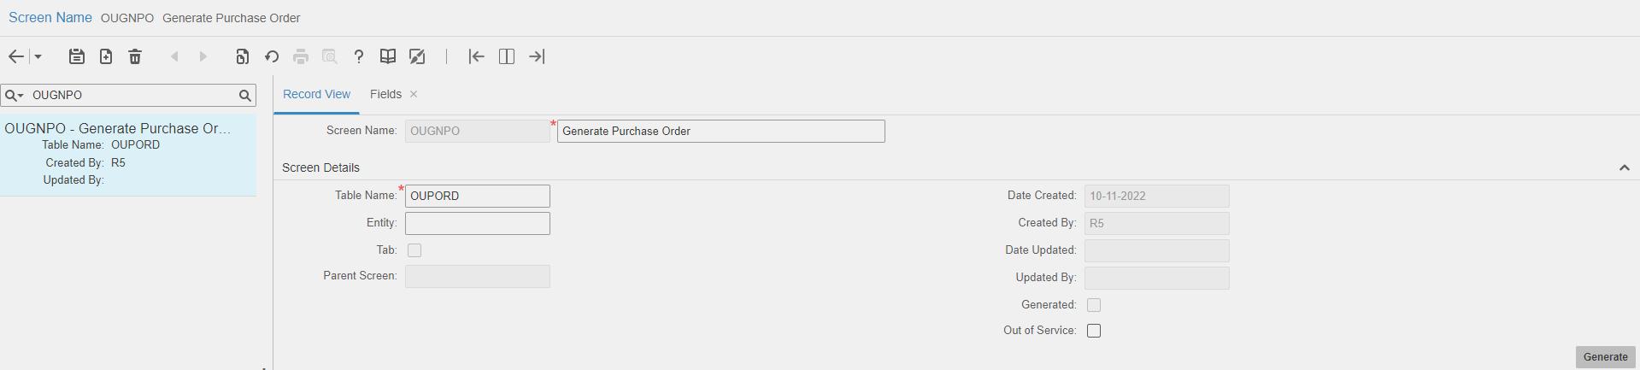

Navigate to Fields

Please refer attached excel file for fields.

2. Extensible Framework: Administrator --> Security --> Extensible Framework
Name: QBUZZ_external_OUWOCF
Screen: OUWOCF

Name: QBUZZ_external_OUGNPO
Screen: OUGNPO

Contents List
The release is contained in compressed file, which contains the following files:
Db scripts
- SPC-292.sql

EF
- QBUZZ_external_OUGNPO.txt
- QBUZZ_external_OUWOCF.txt

Release Note: Qbuzz_release0.0.5_EAM11.7-Qbuzz- New Changes_Release 15 Nov

